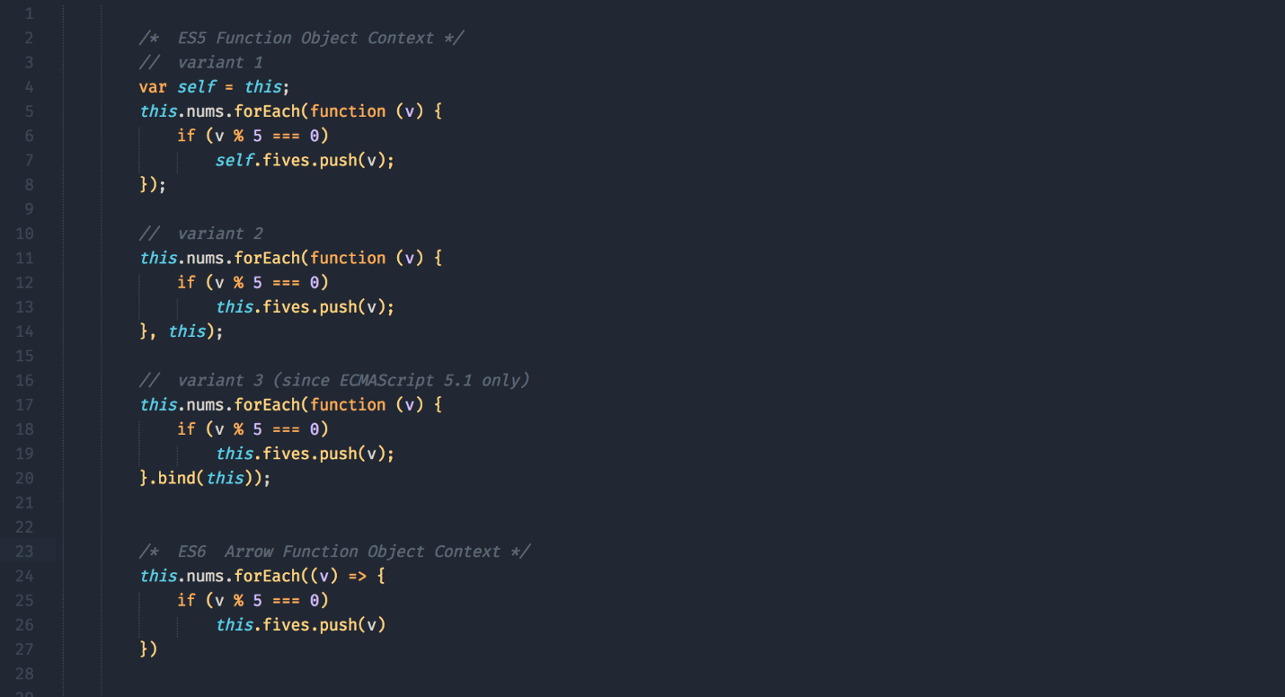

Fat Arrow

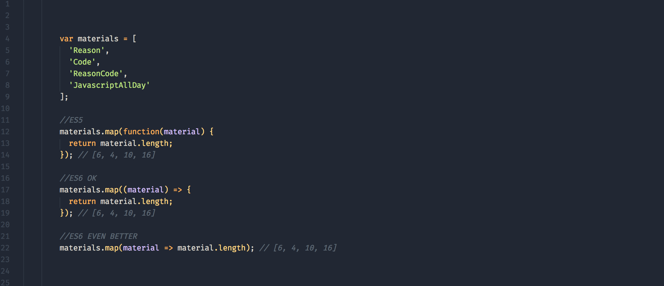

Template literals are string literals allowing embedded expressions. You can use multi-line strings and string interpolation features with them.

By adding the async keyword in front of a function, you are able to defer the execution of code using the await statement. The return value of an async function is implicitly a promise object.

Object.values can be viewed as a more declarative way of executing a for...of

It returns an array of the values for all enumerable keys in the object (excluding values in the prototype chain).

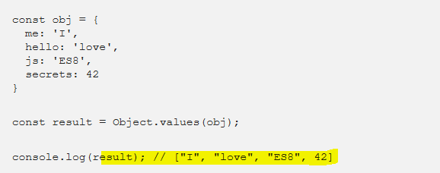

The Object.entries method returns an array of arrays with the key and value in each sub-array.

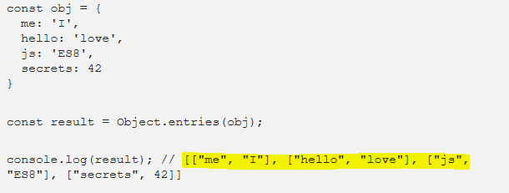

The **Promise.all()** method returns a single [Promise](https://developer.mozilla.org/en-US/docs/Web/JavaScript/Reference/Global_Objects/Promise) that fulfills when all of the promises passed as an iterable have been fulfilled or when the iterable contains no promises or when the iterable contains promises that have been fulfilled and non-promises that have been returned. It rejects with the reason of the first promise that rejects, or with the error caught by the first argument if that argument has caught an error inside it using try/catch/throw blocks.

Hosting

**process.argv** is an array containing the command line arguments. The first element will be 'node', the second element will be the name of the JavaScript file.

1. If a module is in the same folder as the routine that needs the module, what syntax would you use in the require clause?
2. How many arguments are in a standard "callback interface"?
3. What are they?
4. What does the process.argv array contain?
5. What array method did we use to process the entire process.argv array?
6. What elements are not passed parameters?
7. What is yargs?
8. What command did we use to install yargs?
9. What is the last method executed in a yargs command?
10. What do we pass to the .options property of yargs?
11. What option setting can I use to give an alternative name to a parameter?
12. If I run my module without any parameters, and I’ve set the module up with yargs what will I see upon execution?
13. What yargs option did we use to limit the province code to ON or AB?
14. What is the main benefit of using promises?
15. What 2 callbacks do we provide to the promise?
16. What code in the caller of the Promise handles the resolve callback?
17. What code in the caller of the Promise handles the reject callback?
18. What term is used when returning another/different async function from a then?
19. What newer syntax (Since Node 7.6) is available to call promises?
20. T/F the syntax from the previous question is really just syntatic sugar for promises?
21. What keyword is used to pause when calling a promise until it is resolved or rejected?
22. When do you use a promise.all?
23. Did we call the GOC site in lab2 with a promise or a callback?
24. T/F - I can export a function with a different name than the internal name?